**Branching:**

1. **Create a new branch “GitNewBranch”.**



1. **List all the local and remote branches available in the current trunk. Observe the “*” mark which denote the current pointing branch.**



1. **Switch to the newly created branch. **

**Add some files to it with some contents.**

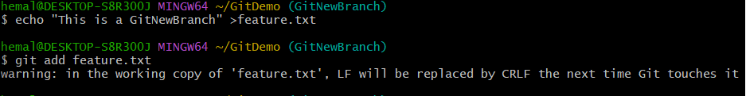

1. **Commit the changes to the branch.**

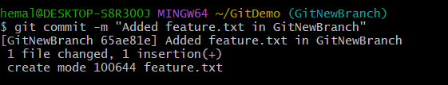

1. **Check the status with “git status” command.**

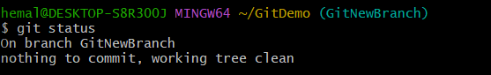

**Merging:**

1. **Switch to the master**

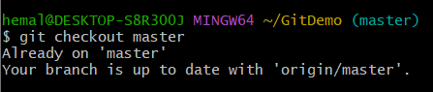

1. **List out all the differences between trunk and branch. These provide the differences in command line interface.**

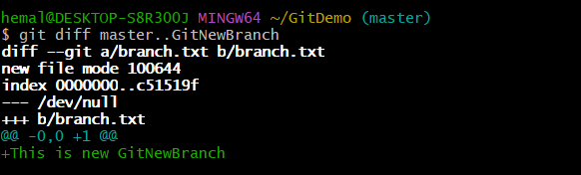

1. **List out all the visual differences between master and branch using P4Merge tool.**

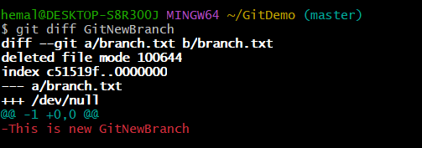

1. **Merge the source branch to the trunk.**



1. **Observe the logging after merging using “git log –oneline –graph –decorate”**

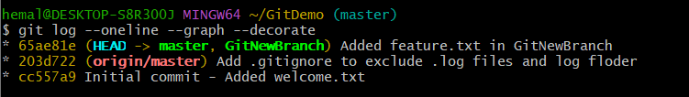

1. **Delete the branch after merging with the trunk and observe the git status.**

